Project Report
STA 567 Fall 2025
Cameron Carter, Maria Dodson, Nazim Pacheco

Introduction & Background
The ability to forecast home prices is always an important task, for both homebuyers and economists. It’s a necessary task to understand economic stability and assist people in financial decision making. For this project we will analyze data of home property sales from 2007 to 2019 to find the process series and use that information to make predictions on future home prices.
Our data set contains housing sale prices in an unspecified region of the United States from 2007 to 2019. The price data was recorded for each fiscal quarter, which is dated as March 31st, June 30th, September 30th, and December 31st. The data was obtained from Kaggle, Housing Property Sales Time Series [1]. The data set contains data on both apartments and houses of different bedroom sizes, for the purpose of this project we will only be using the 4 bedroom house prices. There are 344 house prices, separated by the number of bedrooms for each date. Only looking at the prices of the 4 bedroom homes gives us 51 observations. We expected 52 observations but the price for December of 2019 was not recorded.

Methods
The data was loaded, graphed, and analyzed using R with RStudio. Using the TSA and forecast packages, we plotted, analyzed, and fit the series to a model. After loading in the data, the data was cleaned and unnecessary columns were dropped so only the 4 bedroom house prices ordered by time were left. Then the series graph and ACF was plotted, and checked for stochastic or deterministic behavior. Once stochastic behavior was determined, the series was differenced and graph and ACF was plotted to be checked for stochastic behavior. The series still appeared to have stochastic behavior, so the second difference was taken, and stationarity was seen in the graph and ACF plot. Since no variance issues were seen, there was not a need to take the log transformation. Then the ACF, PACF, and EACF were checked to determine the ARMA process. Once the possible models were determined, the parameters were estimated using maximum likelihood. The goodness-of-fit of the models was determined using AIC, BIC, residual diagnostics like the Ljung-Box test, and Shapiro-Wilk test with Q-Q plot for normality. Once a final model was selected, predictions were made for the next ten future time points, and plotted along with their confidence intervals.

Results & Discussion
Our main objective was to find an ideal model to predict the price for a four bedroom house, given the time series from 2007 through 2019.
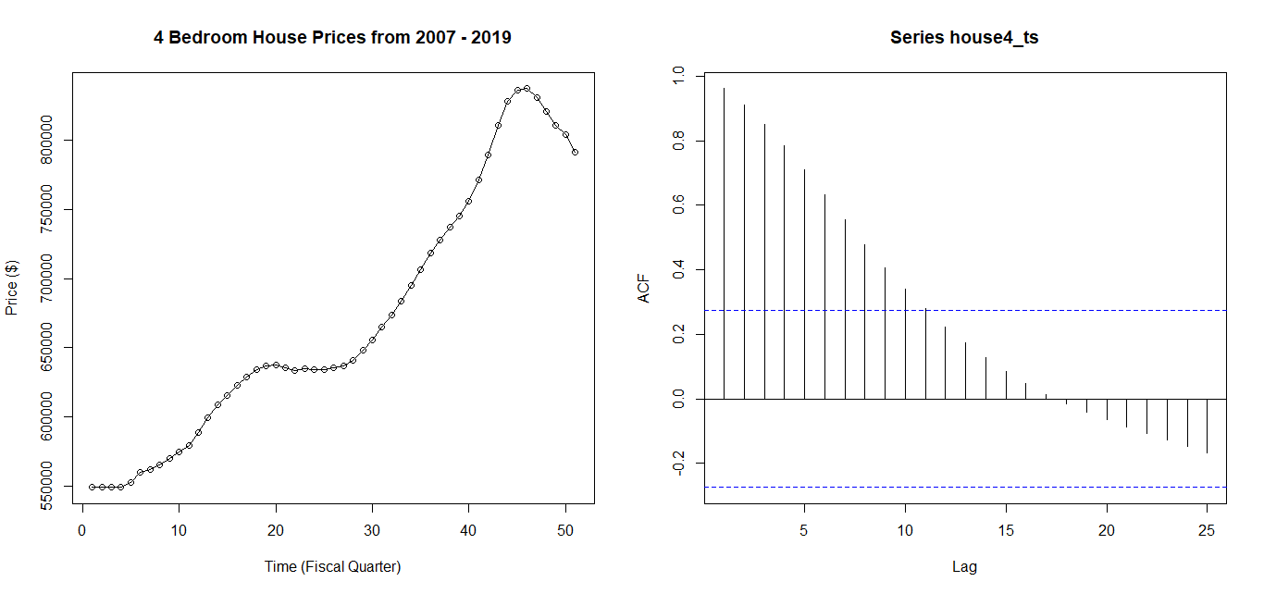
From our above plots, we see that the time series does not appear to fluctuate about a constant mean, and therefore has a steady increase which implies an upward trend. From this alone, we can already declare that our time series is not stationary. Moreover, shifting gears towards variability, we cannot visually explain nor observe the variance over time, since it comprises an upward trend, even though there are periods in the plot where it appears that during some times, the price drastically differs from other points. Visually, we can interpret this to have a stochastic trend that will require differencing to remove the trend, and this is confirmed by our ACF which shows slowly decaying ACF. Therefore, if we combine our observations from the time series plot and the ACF, we can conclude that this time series is not stationary and will require differencing before moving forward with our ACF,PACF, and EACF tools.

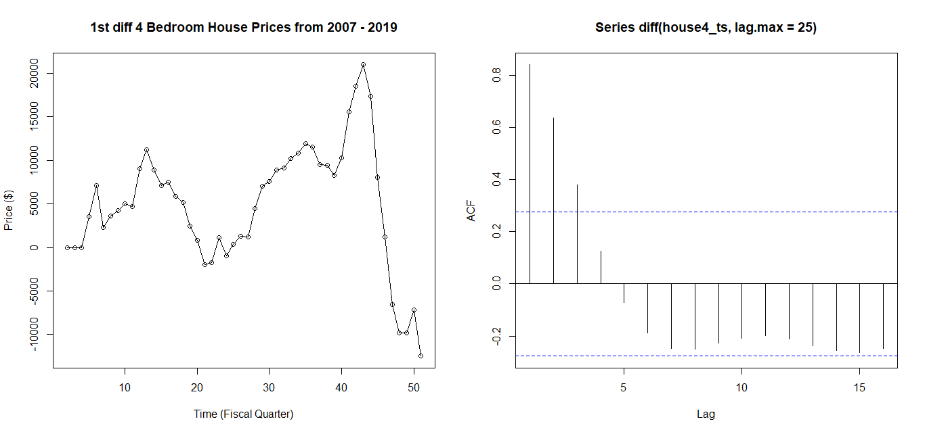

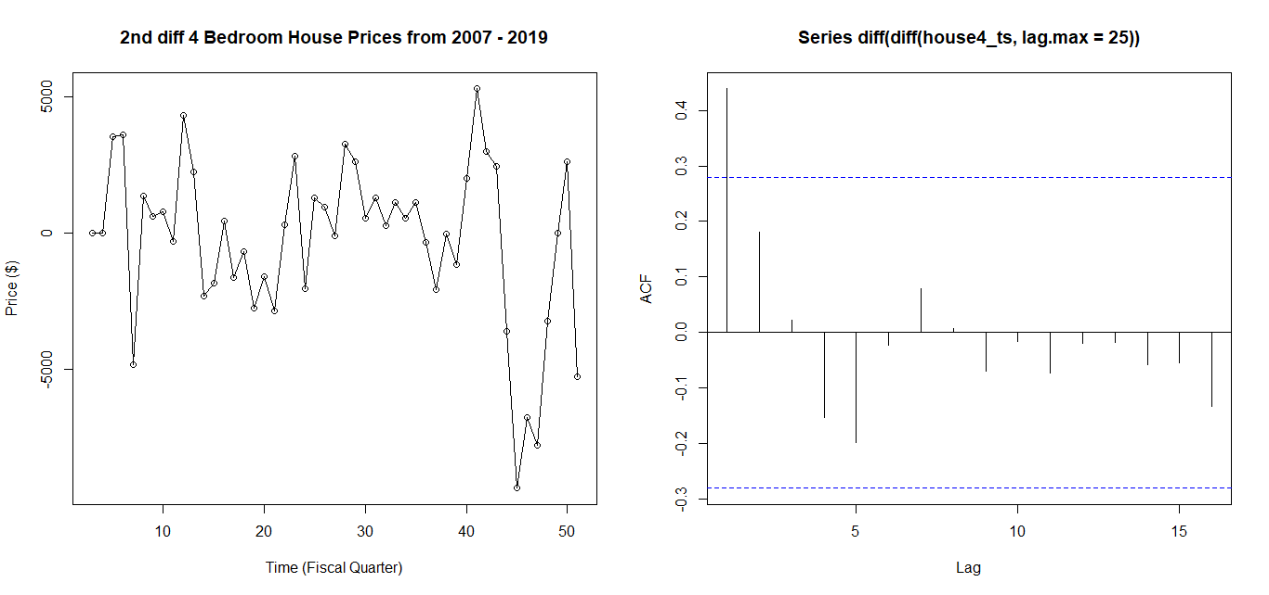
After differencing once, we obtained the above time series and ACF plots. It is apparent that the trend was reduced significantly; however, visually, the time series plot still does not appear to have constant mean nor variance appears stable. When observing the ACF plot on the right, we noticed a decrease in the decaying ACF, but still see some correlation between lags. From both plots, we can conclude that the series does not satisfy stationarity and thus have decided to perform a second differencing. We must remember that we can only employ the ACF, PACF, and EACF tools on stationary data, so a second differencing is crucial at this stage.

Differencing a second time, we now get a more stable time series, with mean appearing mostly constant about zero without any clear trend, while the variance also appears more stable compared to the previous series. Moving on to the ACF plot on the right, we notice that there is only one ACF value that stands above the significance line while the other ACF values are cut off. This is now more stationary-looking, since we no longer see a slowly decaying ACF plot.
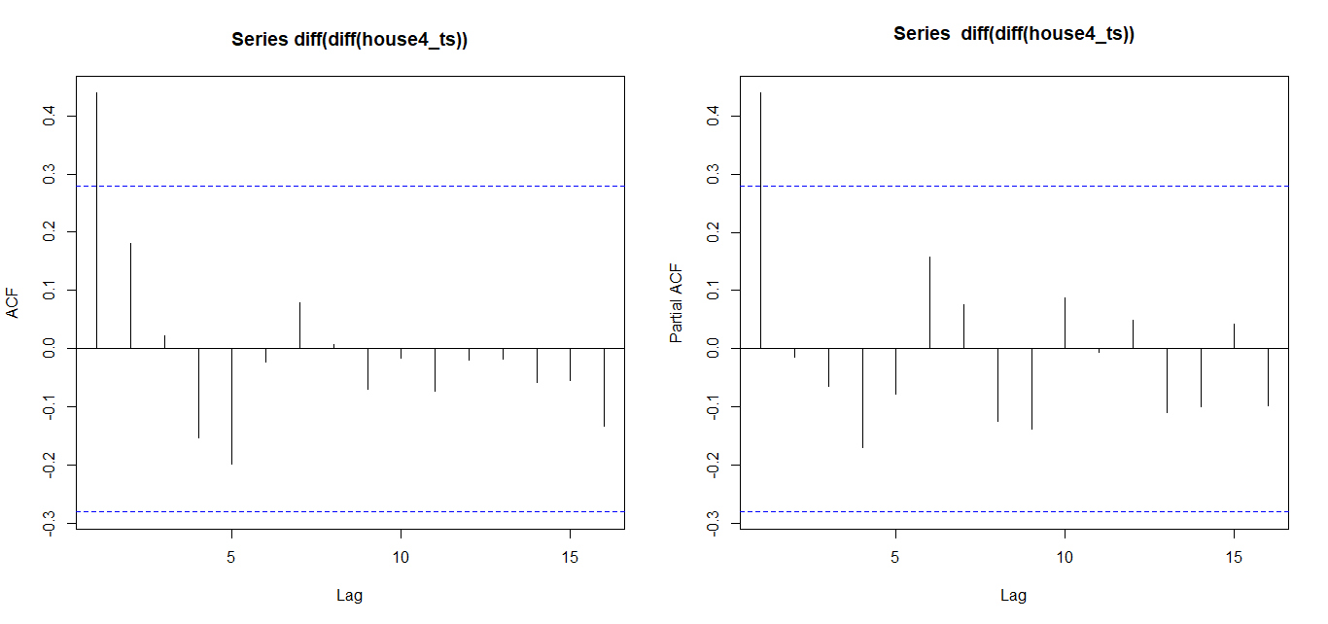
Looking at both ACF and PACF, we immediately see that there is only one ACF value clearly above the line. We already know that for ACF, AR tails off while MA cuts off, and mixed ARMA tails off. For PACF, we also know that AR cuts off and MA tails off and mixed ARMA tails off. For both ACF and PACF, we notice that there appears to be only one long bar. However, we see that for the ACF, there is a bit of a trail behind, which implies some correlation among lags, and then in the PACF, we noticed that then it immediately dropped to zero. From this, we know that it most likely follows the pattern of an AR, and the amount of bars, which in this case is one, would imply that it is AR(1). However, to confirm our suspicion, we can do an EACF to verify.

AR/MA
0 1 2 3 4 5 6 7 8 9 10 11 12 13
0 x o o o o o o o o o o o o o
1 o o o o o o o o o o o o o o
2 x o o o o o o o o o o o o o
3 o o o o o o o o o o o o o o
4 o x o o o o o o o o o o o o
5 o o o o o o o o o o o o o o
6 x x o o o o o o o o o o o o
7 x x o o o o o o o o o o o o

We obtained the output matrix and we look at the top left values to identify the first zeros. AR(p) represents the rows and MA(q) the columns. We know that an upper left hand vertex of a triangle of zero corresponds to the order of the ARMA process. In this case, we note the one highlighted in red corresponds to the AR(1) process; interestingly, we also have another one highlighted as green which corresponds to an MA(1) process. Therefore, we have two competing models: ARIMA(1,2,0) and ARIMA(0,2,1). Fitting both models using maximum likelihood, we then check their goodness-of-fit and residual diagnostic to accurately perform model selection.

AIC/BIC:
Model | AIC | BIC
ARIMA(1,2,0) | 918.5358 | 922.3194
ARIMA(0,2,1) | 917.2989 | 921.0825

First and foremost, looking at our AICs and BICs, we observe that ARIMA(0,2,1) has lower values for both.

ARIMA(0,2,1) - Residual Diagnostics:
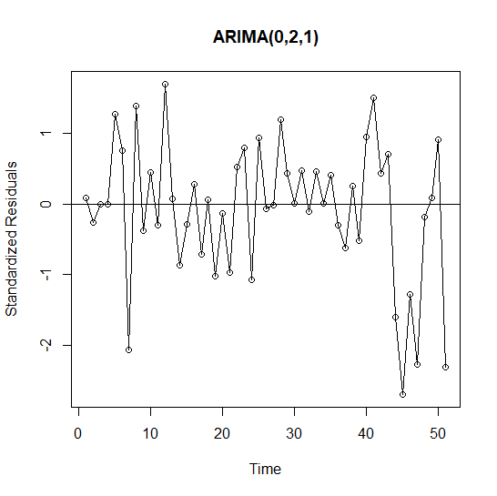
Looking at our standardized residuals plot above, we can see that it does not follow any pattern and the peaks and dips look relatively stable about zero, which implies that the general structure of the data has been captured by the model. We can further analyze and test for normality by showing a Q-Q Plot as well as running the Shapiro-Wilk test.
Shapiro-wilk:

P-value = 0.03863
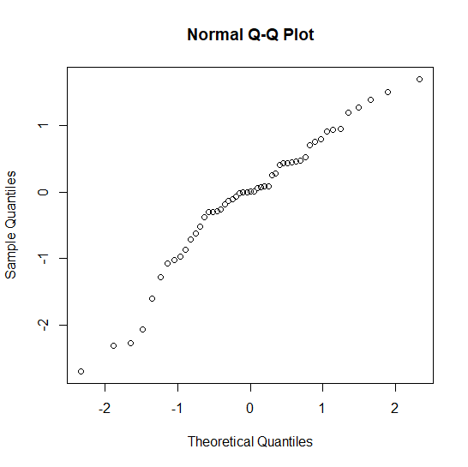

When initially looking at our Q-Q Plot, we immediately notice how the tails tend to deviate away from the line, while the central part of the residuals appears to follow the line, and this brings into question if the residuals actually follow a normal distribution. Running the Shapiro-Wilk test to confirm, we obtained a p-value less than our conventional alpha of 0.05 so we can reject the null hypothesis and conclude that the residuals are not normally distributed.
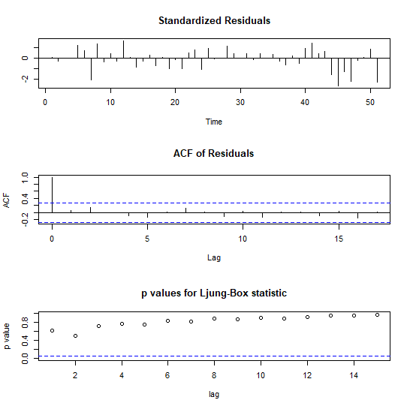
Our above plots display the standardized residuals, ACF residuals, and the Ljung-Box Test. Looking at the standardized residuals, we note that the residuals fluctuate without any clear pattern. Furthermore, looking at the ACF of residuals, we notice that ACF beyond lag zero all fall within the significance line, and therefore implies that the residuals do not show signs of autocorrelation amongst each other. Lastly, looking at our Ljung-Box test, we observe that the p-value is greater than alpha of 0.05, so we fail to reject the null hypothesis and conclude that the residuals are independent of each other, and this means that our model captured the patterns in the data. From the above, we can conclude that the ARIMA(0,2,1) fits the data very well.

Our Alternative Model: ARIMA(1,2,0)
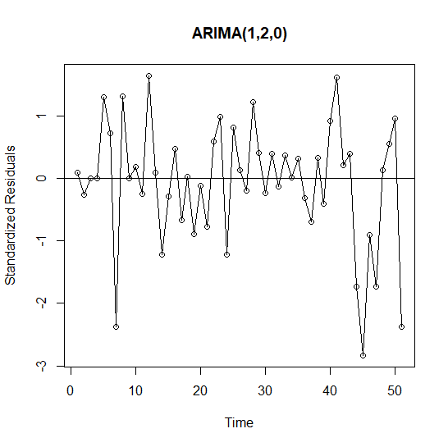
Looking at the standardized residuals plot for the ARIMA(1,2,0) model, we notice that the residuals fluctuate around the zero line and show no apparent signs of trend. This implies that the model does a very good job at capturing the data structure. We can look further into it by checking for normality by a Q-Q Plot and a Shapiro-Wilk test.
Shapiro-Wilk

P-value: 0.01805
A p-value less than our conventional alpha, we reject the null hypothesis and conclude that the residuals are not normally distributed.
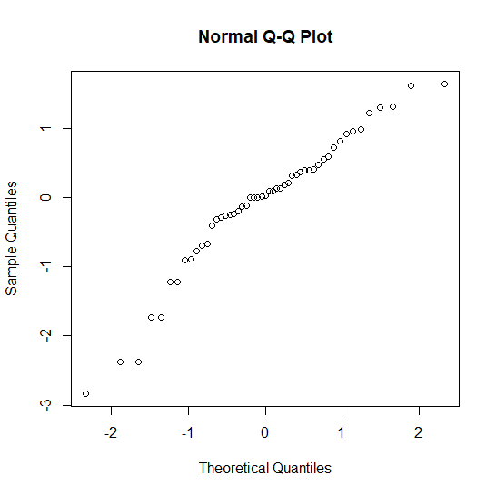
When looking at the Q-Q Plot above, we can see that the tails of the residuals deviate significantly more compared to our previous model’s Q-Q Plot. The middle portion of the plot still looks steady and the residuals clearly follow the line for the most part, but it is in the tails where we notice the greater deviations from the line. From this, we can also visually interpret it to not be normally distributed, but we already confirmed with our Shapiro-Wilk test earlier.
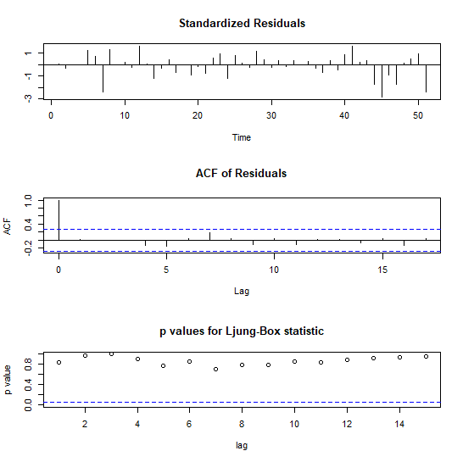
From our three plots above, we get a better understanding of the residual diagnostics and how well the model fits the data. Firstly, looking at the standardized residuals plot, we notice that the bars fluctuate about zero and show no clear pattern within. Moving to the ACF of residuals plot, we notice that there is non significant autocorrelation after lag zero, which means that the residuals do not show autocorrelation amongst each other. Lastly, looking at the Ljung-Box Test, we observe that the p-value is greater than alpha so we fail to reject the null hypothesis and conclude that the residuals are independent and no correlation exists among the residuals. From these three, we can conclude that the model also fits the data well.
Final Model Selection
The two competing models were ARIMA(1,2,0) and ARIMA(0,2,1). Our residual diagnostics pointed towards ARIMA(0,2,1) being a better fit model. Both models produced residuals that were stable and did not show signs of autocorrelation. When testing for normality, we noticed that the ARIMA(0,2,1) had a higher p-value produced by the Shapiro-Wilk test and the Q-Q Plot appeared to be more consistent with the line while the ARIMA(1,2,0) model showed signs of the tails being more deviated which suggests poor residual structure in terms of normality. Also, both models did well for the Ljung-Box Test, in which the produced p-values were higher than alpha and hence meant that the residuals were independent of each other. Lastly, an important metric to determine the best model utilized was the AIC/BIC, in which the model with lower scores was selected, and in this case the ARIMA(0,2,1) model showed lower AIC and BIC values and was therefore selected as our final model.
Forecasting
With ARIMA(0,2,1) selected as our model, we will predict the values for the next ten time points, which cover December, 2019 to March, 2022. Plotting these predictions along with the 95% confidence interval for each prediction, we can see a continuation of the decrease in prices. Looking at the upper bound values of our predictions, we can see the possibility for an increase in prices instead of a decrease. We can see the standard errors increase over time, which means the uncertainty of our predictions is increasing for the long term predictions.
forecast se l u
1 776211.4 2757.501 770806.7 781616.1
2 760976.8 7252.726 746761.5 775192.2
3 745742.2 12892.194 720473.5 771010.9
4 730507.7 19484.293 692318.5 768696.9
5 715273.1 26909.164 662531.1 768015.0
6 700038.5 35083.030 631275.8 768801.2
7 684803.9 43943.136 598675.4 770932.5
8 669569.3 53440.227 564826.5 774312.2
9 654334.7 63534.313 529807.5 778862.0
10 639100.2 74192.092 493683.7 784516.7
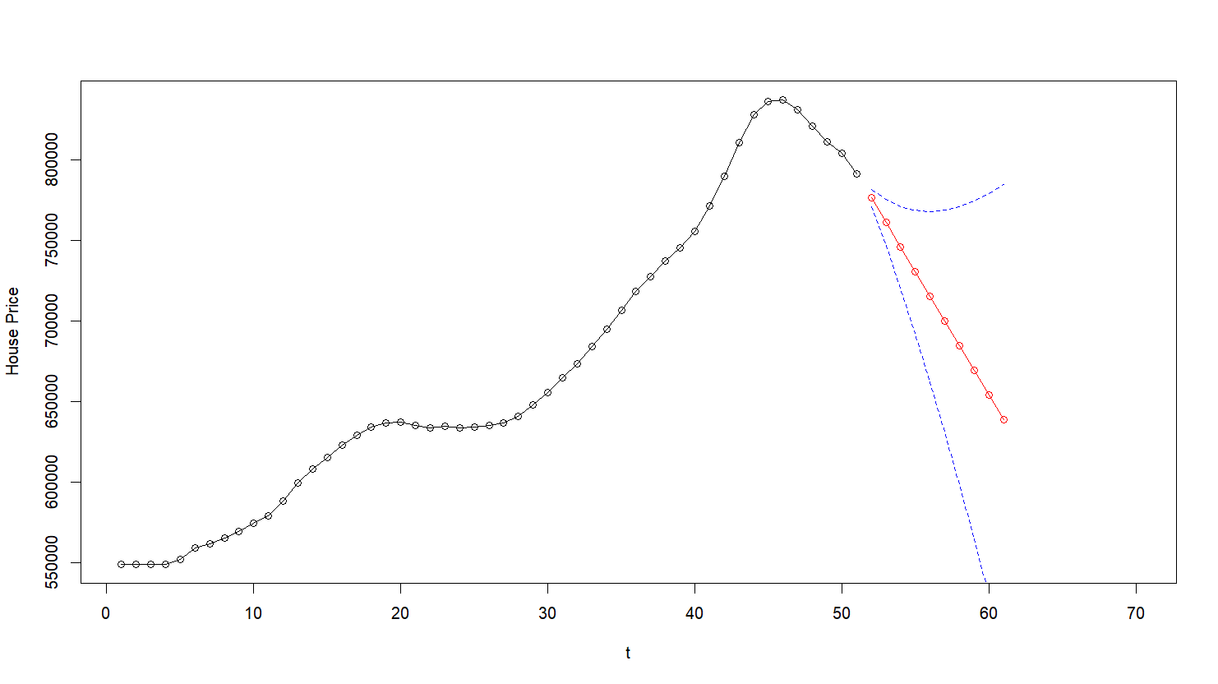
Summary
With ARIMA(0,2,1) as our final model and predictions made for the next ten time points, we can see that home prices are predicted to decrease over the next 2.5 years. If we look at actual home price forecasting in the U.S., the downward trend was predicted for that time, however what actually happened was home prices increase due to the COVID-19 pandemic during 2020. Since the underlying process is a moving average, home prices do not have a consistent average price, the average changed over time. This is what we expected to see in the trend of home prices, caused by changes in the economy, inflation, and unpredictable world events. Further analysis of home prices with more current data and more home prices using our model would provide helpful insight into the home buying market.

Appendix (R Code)
# STA 567 Project Report
# Cameron Carter, Maria Dodson, Nazim Pacheco

require(TSA)
require(utils)
require(dplyr)
library(car)
library(MASS)
library(plyr)
library(lattice)
library(ppcor)
library(stats)
library(forecast)
# Import the "ma_lga_12345.csv"
data <- read.csv("https://raw.githubusercontent.com/JCameronCarter/TimeSeriesGroupProject/refs/heads/main/ma_lga_12345.csv")
house_ts <- data[data$bedrooms == 4,]
house4_ts <- ts(house_ts[,-c(1,3,4)])
options(scipen=10)
par(mfrow=c(1,2))
plot(house4_ts, type='o', ylab="Price ($)",
main='4 Bedroom House Prices from 2007 - 2019',xlab ='Time (Fiscal Quarter)')
acf(house4_ts,lag.max=25)

par(mfrow=c(1,2))
plot((diff(house4_ts)), type='o', ylab="Price ($)",
main='1st diff 4 Bedroom House Prices from 2007 - 2019',xlab ='Time (Fiscal Quarter)')
acf(diff(house4_ts,lag.max=25))

par(mfrow=c(1,2))
plot(diff(diff(house4_ts)), type='o', ylab="Price ($)",
main='2nd diff 4 Bedroom House Prices from 2007 - 2019',xlab ='Time (Fiscal Quarter)')
acf(diff(diff(house4_ts,lag.max=25)))

par(mfrow=c(1,2))
acf(diff(diff(house4_ts)));pacf(diff(diff(house4_ts)))
eacf(diff(diff(house4_ts)))

m1<-Arima(house4_ts,order=c(0,2,1),include.mean=F, method='ML') # Parameter estimation of ARIMA (0,2,1)
m2<-Arima(house4_ts,order=c(1,2,0),include.mean=F, method='ML') # Parameter estimation of ARIMA (1,2,0)
data.frame(Model=c("ARIMA(1,2,0)","ARIMA(0,2,1)"), AIC=c(AIC(m1),AIC(m2)),
BIC=c(BIC(m1),BIC(m2)))

par(mfrow=c(1,1))
ts.plot(rstandard(m1),ylab="Standardized Residuals",main="ARIMA(0,2,1)",type="o")
abline(h=0)
tsdiag(m1,gof.lag=15,omit.initial=F)

par(mfrow=c(1,1))
ts.plot(rstandard(m2),ylab="Standardized Residuals",main="ARIMA(1,2,0)",type="o")
abline(h=0)
tsdiag(m2,gof.lag=15,omit.initial=F)

par(mfrow=c(1,1))
summary(m1)
qqnorm(rstandard(m1))
shapiro.test(rstandard(m1))# formal test for normality

par(mfrow=c(1,1))
summary(m2)
qqnorm(rstandard(m2))
shapiro.test(rstandard(m2))# formal test for normality

# Picking ARIMA(0,2,1), (m1) because it fits the best

#-------------Making 1st 10 prediction
m1.pr<-predict(m1,n.ahead=10) # Forecasting TS at 10 future time points
forecast=m1.pr$pred;se=m1.pr$se
l<-forecast-1.96*se
u<-forecast+1.96*se
data.frame(forecast,se,l,u)

#---------------------Constructing 95% upper and lower bound around the forecast
# plotting forecast values with given CI along with the data
par(mfrow=c(1,1))
t<-1:70 # Only showing the partial series
plot(t,house4_ts[t],type="o",ylab="House Price")
lines(forecast,col="red",type="o")
lines(u,col="blue",lty="dashed")
lines(l,col="blue",lty="dashed")

#--------Making and plotting predictions 10 timesteps in the past

ts_len <- length(house4_ts)
m1_trimmed1 <-Arima(house4_ts[0:(ts_len-10)],order=c(0,2,1),include.mean=F, method='ML')

m1_trimmed1.pr<-predict(m1_trimmed1,n.ahead=10) # Forecasting TS at 10 future time points
forecast_t1 <- m1_trimmed1.pr$pred;se_t1=m1_trimmed1.pr$se
l_t1<-forecast_t1 - 1.96*se_t1
u_t1<-forecast_t1 + 1.96*se_t1
data.frame(forecast_t1,se_t1,l_t1,u_t1)

plot(house4_ts, ylim=c(550000,950000), type="o", ylab="House Price", main="10 timesteps in the past")
mtext(expression(Y[41]),side = 3, line = 0.25)
lines(forecast_t1,col="red",type="o")
lines(u_t1,col="blue",lty="dashed")
lines(l_t1,col="blue",lty="dashed")

#--------Making and plotting predictions 6 timesteps in the past

m1_trimmed2 <-Arima(house4_ts[0:(ts_len-5)],order=c(0,2,1),include.mean=F, method='ML')
m1_trimmed2.pr<-predict(m1_trimmed2,n.ahead=10)
forecast_t2 <- m1_trimmed2.pr$pred;se_t2=m1_trimmed2.pr$se
l_t2<-forecast_t2 - 1.96*se_t2
u_t2<-forecast_t2 + 1.96*se_t2
data.frame(forecast_t2,se_t2,l_t2,u_t2)

plot(house4_ts, ylim=c(550000,950000), xlim=c(0,55),type="o", ylab="House Price", main="5 timesteps in the past")
mtext(expression(Y[46]),side = 3, line = 0.25)
lines(forecast_t2,col="red",type="o")
lines(u_t2,col="blue",lty="dashed")
lines(l_t2,col="blue",lty="dashed")

References
[1] Housing Property Sales Time Series. HtAG Holdings. Retrieved from https://www.kaggle.com/datasets/htagholdings/property-sales?select=ma_lga_12345.csv

